Nama | : Hafied Mustaman
NBI | : 1461700138
Kelas | : D9
Praktikum | : Dasar Pemrograman
Tugas Akhir Praktikum | : 4 | ACC DOSBIM | ACC ASLAB

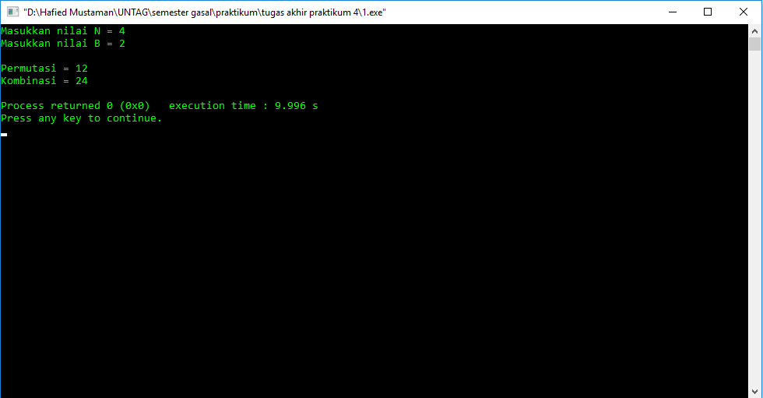
- program untuk permutasi dan kombinasi
#include <iostream>
#include <conio.h>
using namespace std;
int faktorial(int n)
{
if(n==1)
return 1;
else
return n*faktorial(n-1);
}
int main()
{
int n, b, total, permutasi, hasil, kombinasi, temp;
cout<<"Masukkan nilai N = "; cin>>n;
cout<<"Masukkan nilai B = "; cin>>b;
total=faktorial(n);
temp=n-b; cout<<endl;
permutasi=faktorial(n)/faktorial(temp);
kombinasi=faktorial(n)/faktorial(b)*faktorial(temp);
cout<<"Permutasi = "<<permutasi<<endl;
cout<<"Kombinasi = "<<kombinasi<<endl;
return 0;
}

- Program perkalian 2 matriks random 3x3 dengan menggunakan fungsi
#include <iostream>
#include <conio.h>
#include <iomanip>
#include <stdlib.h>
#include <time.h>
using namespace std;
void matriks(int acak)
{
int baris1, kolom1, baris2, kolom2;
cout<<"\nMatriks A"<<endl;
cout<<"Masukkan baris = "; cin>>baris1;
cout<<"Masukkan kolom = "; cin>>kolom1;
int a[baris1][kolom1]; cout<<endl;
for(int i=0; i<baris1; i++)
{
for(int j=0; j<kolom1; j++)
{
a[i][j]=1+rand()%acak;
cout<<"Angka baris "<<i+1<<",kolom "<<j+1<<" = "<<a[i][j]<<endl;
}
}
cout<<endl;
for(int i=0; i<baris1; i++)
{
for(int j=0; j<kolom1; j++)
{
cout<<setw(8)<<a[i][j]; cout<<endl;
}
}
baris2=kolom1;
cout<<"\nMatriks B"<<endl;
cout<<"Masukkan baris = "<<baris2<<" (baris matriks B akan
menyesuaikan kolom matriks A)"<<endl;
cout<<"Masukkan kolom = "; cin>>kolom2;
int b[baris2][kolom2]; cout<<endl;
for(int i=0; i<baris2; i++)
{
for(int j=0; j<kolom2; j++)
{
b[i][j]=1+rand()%acak;
cout<<"Angka baris "<<i+1<<",kolom "<<j+1<<" = "<<a[i][j]<<endl;
}
}
cout<<endl;
for(int i=0; i<baris2; i++)
{
for(int j=0; j<kolom2; j++)
{
cout<<setw(8)<<b[i][j]; cout<<endl;
}
}
int hasil[baris1][kolom2];
cout<<"\nHasil Perkalian Matriks A & Matriks B"<<endl;
for(int i=0; i<baris1; i++)
{
for(int j=0; j<kolom2; j++)
{
hasil[i][j];
for(int k=0; k<baris2; k++)
{
hasil[i][j]+=a[i][k]*b[k][j];
}
cout<<setw(8)<<hasil[i][j];
}
cout<<endl;
}
}
int main()
{
int acak;
char cobalagi;
srand(time(NULL));
do
{
system("cls");
cout<<"Masukkan batas random angka = "; cin>>acak;
matriks(acak);
cout<<"Apakah anda ingin mengulanginya lagi? (Y/N)"<<endl;
cin>>cobalagi;
}
while(cobalagi == 'Y');
getch();
return 0;
}

